This is a logbook entry to complete and email to your faculty supervisor as progress update on a biweekly basis (i.e. once every 2 weeks). Your submissions will be used as reference for your internship progress and will be assessed towards the overall performance of your internship journal.

Important Note:
- As consistency of submissions is assessed as part of your internship, all submissions should be made on time. Any delays should be informed and prior approval to be sought with your faculty supervisor. Late entries without prior approval will be considered invalid for assessment.
- Before submission, please obtain clearance for your logbook content from your organisation supervisor to ensure that no confidential information is included.

Student Name | : | Tan Yi Rong
Student ID | : | U2320967K
Company Name | : | GlobalFoundries
Company Supervisor | : | Ng, Christopher
Logbook Entry Period | : | 25/05/2025 to 07/05/2025
Date of Submission | : | 09/09/2025

- State the Internship Objective, Scope, and Problem Statement
(Briefly describe the objective(s) provided by the internship organisation, and the expected scope of work and deliverables expected from you to address the issues.)
Objective:
The objective of this internship is to support the Automated Material Handling System (AMHS) department in improving Overhead Hoist Transport (OHT) maintenance data collection and predictive maintenance requirements for parts replacement. This is intended to reduce error occurrences and improve operational performance during production.

Scope of Work:
- Understudy AMHS operation and OHT Preventive Maintenance (PM) process during the initial stage of the internship.
- Continuation of Project Odin, which focuses on OHT wheel measurement through sensor testing and data collection for Predictive Maintenance.
- Carry out preliminary industry-attached FYP scoping and research related to AMHS and OHT maintenance improvement.
- Attend team meetings, daily progress reviews and support documentation and other ad-hoc AMHS-related tasks where required.

Problem Statement:
The current OHT maintenance and condition monitoring process requires more effective and reliable methods of data collection, analysis and maintenance planning. Without sufficient monitoring and process improvement, maintenance activities may remain reactive, labour-intensive and more prone to inconsistency. This internship focuses on understanding current workflow, supporting ongoing wheel monitoring and Predictive Maintenance (PdM) efforts and exploring ideas that may improve maintenance efficiency, safety and ease of line support work.

- Describe your work done over the past 2 weeks
Work and/or Tasks Performed | Date (From) | Date (To)
Sketchup on OHT Maintenance Bay | 08/06/26 | continuation
Generating project slide deck for vendors and supervisor | 08/06/26 | 010/06/26
Vendor engagement and technical discussion | 11/06/26 | 12/06/26
Project evaluation and feasibility study work | 11/06/26 | 12/06/26
Software development (in progress) | 15/06/26 | continuation

Describe and reflect on your work/task outcome/learning over the last 2 weeks

(Illustrate the challenges that you are facing; describe areas that you have done well and areas that could be better managed)

WORK DONE
During this period, work focused on further developing the proposed automation solution for the OHT Mark 2 PM process. While continuing to refine the project scope, meetings and presentations were conducted with representatives from OMRON and Universal Robots (UR) to provide them with a better understanding of the current manual PM workflow and the proposed automation concept.
A presentation deck was prepared and presented to both vendors to explain the existing PM procedure, the challenges faced in the manual process and the intended automation objectives. Discussions helped to gather information regarding their robot capabilities, vision systems, software integration option, deployment requirements and estimated price ranges. These discussions provided valuable insights into feasibility of using a collaborative robot for connector handling, sensor verification and future automation of the PM process.
In parallel, work continued the software aspect of the project while awaiting further vendor feedback. Research was carried out on how the PM process can be supported through a dedicated software application that manages test sequencing, operator guidance, acceptable range verification, screenshot capture and result documentation. After evaluating different approaches, a semi-automated workflow was identified as a more practical implementation strategy compared to a fully automated solution, as it allows technicians to remain involved at key verification checkpoints.
An initial offline windows-based simulator was also developed in C# to validated software workflow and user interface design. The simulator includes PM sequence management, operator controls, run logging, screenshot generation and local file storage functionality. The interface layout was further refined to allocate space for future integration of sensor waveform displays and robot vision feedback.
KNOWLEDGE AND SKILLS GAINED
Through discussions with OMRON and UR, a better understanding was gained regarding the capabilities and limitations of collab robots in industrial environments. This included knowledge of robot payload considerations, positioning accuracy, software integration methods, vision-assisted application and typical deployment costs.
The vendor engagement also provided insight into the practical considerations required when transitioning a concept into an implementable automation solution. Rather than focusing solely on hardware selection, successful implementation requires alignment between the robot system, sensor interface, vision system, software architecture and operational workflow.
From the software development work, additional knowledge was gained in designing offline industrial applications using C# and WinForms. Experience was also gained in developing workflow logic, user interface, data logging functions and file management systems within restricted enterprise IT environment.
CHALLENGES FACED
One of the main challenges during this period was that the project is still dependent on vendor feedback and technical discussions before a suitable hardware platform can be selected. While both vendors have provided preliminary information, further clarification is required regarding integration feasibility, implementation complexity and overall project cost.
Another challenge was balancing progress on the software prototype while hardware remain undefined. As a result, portions of the software can currently only be developed and tested in a simulated environment until actual hardware interfaces can be confirmed. Restrictions to the plugin installations poses as a hurdle as well which led me to use a older certified version for C# to run.

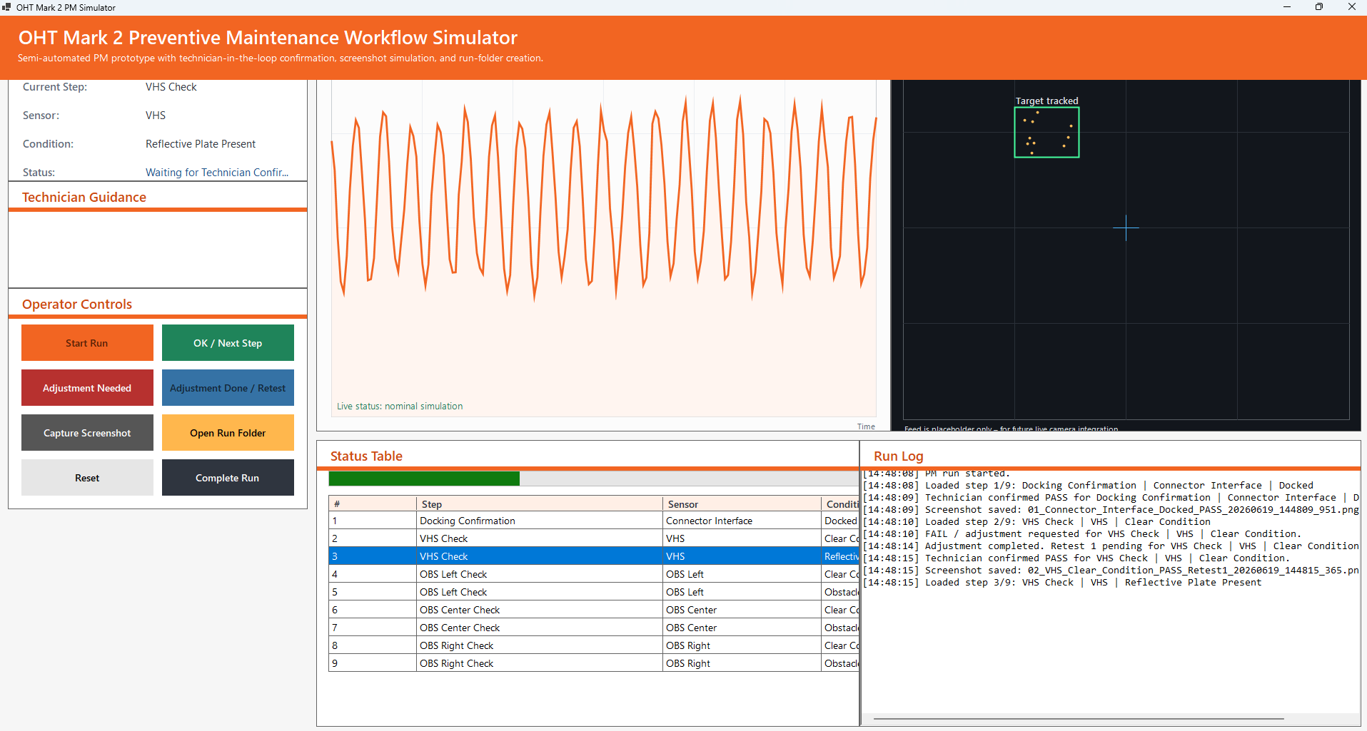
User Interface for Preventive Maintenance Workflow Simulator

